**A**

**MINI PROJECT REPORT**

**on**

**Weather predicition system**

**BE(IT)-III Sem**

**By**

**A. Kunal (160122737170)**

**B. Gowtham (160122737171)**

**B. Srikar (160122737172)**

**Under guidance of**

**Mr. B. Harish Goud**

**Assistant professor**

**IT Department**



**DEPARTMENT OF INFORMATION TECHNOLOGY**

**CHAITANYA BHARATHI INSTITUTE OF TECHNOLOGY (A)**

**(Affiliated to Osmania University; Accredited by NBA(AICTE) and NAAC(UGC), ISO Certified 9001:2015)**

**KOKAPET(V),GANDIPET(M),RR District HYDERABAD - 75**

**Website:** [**www.cbit.ac.in**](http://www.cbit.ac.in/)

**2022-2023**



This is to certify that the project work entitled “Weather Prediction using Machine Learning” submitted to CHAITANYA BHARATHI INSTITUTE OF TECHNOLOGY, in partial fulfillment of the requirements for the completion of Mini Project-I of III Semester B.E. in Information Technology, during the Academic Year 2021-2022, is a record of original work done by B.Srikar(160122737172) and B.Gowtham(160122737171) and A.Kunal(160122737170) during the period of study in the Department of IT, CBIT, HYDERABAD, under our guidance.

|  |  |
| --- | --- |
| **Project Guide** | **Head of the Department** |
| **Mr. B. Harish Goud** | **Dr. A. Rajinikanth** |
| Assistant Professor, Dept. of IT, | Professor, Dept. of IT, |
| CBIT, Hyderabad. | CBIT, Hyderabad. |

## **ACKNOWLEDGEMENTS**

We would like to express our heartfelt gratitude to Mr. U. Sairam , our project guide, for his invaluable guidance and constant support, along with her capable instruction and persistent encouragement.

We are grateful to our Head of Department, Dr. K. Radhika, for her steady support and for the provision of every resource required for the completion of this project.

We would like to take this opportunity to thank our Principal, Dr. P. Ravinder Reddy, as well as the Management of the Institute, for having designed an excellent learning atmosphere.

Our thanks are due to all members of the staff and our lab assistants for providing us with the help required to carry out the groundwork of this project.

**ABSTRACT**

This report outlines the design and implementation of a sophisticated weather prediction system leveraging modern web technologies, including HTML, CSS, and JavaScript. The system provides users with real-time weather data and forecasts for diverse global locations. Emphasis is placed on intuitive user interaction and aesthetically pleasing visual presentation, with dynamic content updates ensuring the latest weather information is readily accessible.

CSS styling principles are meticulously applied to enhance the application's visual appeal, focusing on layout, typography, and a harmonious color scheme. Responsive design methodologies are employed to guarantee seamless user experiences across various devices and screen sizes.

JavaScript plays a pivotal role in orchestrating seamless integration with the OpenWeatherMap API, facilitating the retrieval of weather data based on user input or geolocation. Robust time and date functionalities are implemented to accurately represent temporal aspects of weather forecasts. Furthermore, comprehensive error-handling mechanisms gracefully manage API requests and responses, ensuring uninterrupted service delivery

In conclusion, this weather prediction system serves as a testament to the effective utilization of HTML, CSS, and JavaScript in crafting a professional-grade web application. Its user-centric design and feature-rich functionality set a benchmark for intuitive and informative weather forecasting platforms. Potential avenues for future development include the incorporation of advanced features such as location-based alerts and customizable user preferences, further elevating the system's utility and user experience.

**CONTENTS**

|  |  |  |
| --- | --- | --- |
| S.NO | Topics | Page No. |
|  | List of figures |  |
|  | List of tables |  |
|  | Abbreviations |  |
|  | Abstract |  |
| 1 | Introduction   1. Motivation 2. Problem statement |  |
| 2 | Existing system |  |
| 3 | Proposed methodology   1. System specifications 2. System design |  |
| 4 | Datasets and Algorithms/ models |  |
| 5 | Implementation and Results |  |
| 6 | Conclusion and Future scope |  |
|  | References |  |

**ABSTRACT**

This seminar presents a comprehensive overview of a weather prediction system designed to provide real-time weather data and forecasts to users worldwide. The system's significance lies in its intuitive user interface, seamless integration with external weather data APIs, and robust error handling mechanisms. Objectives include delivering accurate weather information, optimizing system performance, and enhancing user experience across different devices. Methodology involves leveraging modern web technologies and implementing responsive design principles for optimal viewing. Major findings highlight the system's reliability, fast response times, and ability to meet user needs effectively. Overall, the seminar emphasizes the importance of accessible and accurate weather forecasting systems in today's digital age.

Key features include dynamic content updates for current weather conditions and future forecasts, ensuring users have timely access to accurate data. The system's intuitive user interface prioritizes usability and accessibility, catering to a diverse range of users across different devices and screen sizes. Implementation involves leveraging external weather data APIs for data retrieval, with error handling mechanisms in place to maintain uninterrupted service delivery. Additionally, performance optimization techniques guarantee fast response times, enhancing overall user experience. This seminar underscores the critical role of innovative weather prediction systems in empowering individuals and communities to make informed decisions in response to changing weather conditions.

**INTRODUCTION**

1. **MOTIVATION**

The motivation behind undertaking this project stems from the ubiquitous nature of weather forecasting in our daily lives and the increasing reliance on digital platforms for accessing timely and accurate information. Weather conditions profoundly impact various aspects of society, including travel, agriculture, outdoor activities, and disaster preparedness. However, existing weather prediction systems often suffer from usability issues or lack comprehensive features, presenting an opportunity to develop a more sophisticated solution. By leveraging HTML, CSS, and java script technologies, we aim to create a user-friendly weather prediction system that offers intuitive interaction and visually appealing presentation of weather data.

In summary, this project is driven by a commitment to leveraging cutting-edge web technologies to develop a weather prediction system that prioritizes user experience, accessibility, reliability, and educational value. By addressing these motivations, we endeavor to create a valuable resource that empowers individuals and communities to make informed decisions in response to changing weather conditions.

1. **PROBLEM STATEMENT**

Despite the availability of numerous weather forecasting applications and websites, there exists a need for a user-centric and feature-rich weather prediction system that seamlessly integrates with modern web technologies. Existing solutions often suffer from usability issues, lack real-time accessibility, or fail to provide comprehensive features tailored to diverse user needs. Therefore, the problem statement for this project revolves around the following key challenges:

* + - 1. Usability and User Experience
      2. Real-Time Accessibility
      3. Cross-Platform Compatibility
      4. Reliability and Accuracy

**EXISTING SYSTEM**

The existing weather forecasting systems typically rely on external APIs (Application Programming Interfaces) to retrieve weather data from reputable sources such as OpenWeatherMap, Weather.com, or Accurate Weather. These APIs provide developers with access to a wealth of weather-related information, including current conditions, forecasts, historical data, and more.

Developers obtain API keys from the weather data provider, which serve as authentication credentials to access the API endpoints. These keys are unique identifiers that allow the provider to track usage and manage access to their services. The system sends HTTP requests to the API endpoints, specifying parameters such as location coordinates, city names, or postal codes. The API processes these requests and returns weather data in a structured format, often in JSON or XML.

Upon receiving the API response, the system parses the data to extract relevant information, such as current temperature, humidity, wind speed, and precipitation forecasts. This data is then formatted and displayed to the user through the application interface. The system implements error-handling mechanisms to gracefully manage situations where API requests fail or encounter errors. This ensures a smooth user experience and prevents disruptions in accessing weather information.

The weather forecasting system caters to various types of clients, including web applications, mobile apps, desktop widgets, and other digital platforms. These clients leverage the weather data provided by the system to offer users timely and accurate weather forecasts tailored to their needs. 6. Developers have the flexibility to customize the system according to client requirements, such as integrating additional features like radar maps, severe weather alerts, or historical data analysis. This customization enhances the utility and value of the system for end-users.

Overall, the existing weather forecasting system relies on API technology to access and retrieve weather data from external sources, providing clients with the means to offer comprehensive and reliable weather information to their users. The use of API keys ensures secure and authorized access to the data, while error handling mechanisms ensure uninterrupted service delivery.

**PROPOSED METHODOLOGY**

System specifications

**Platform: Web-based**: - Intuitive and visually appealing design with containers for displaying weather information. Ensuring optimal viewing experience across various devices and screen sizes.

**Programming Languages**: HTML for structure, CSS for styling, JavaScript for interactivity. - Fetch API library for making HTTP requests to the Open Weather Map API

Handling API responses, parsing JSON data, and formatting for display.

**Hardware:** Client-side: Any device with a web browser (e.g., desktop computers, laptops, tablets, smartphones). Hosting on cloud platforms like AWS, Google Cloud, or Heroku

APIs: Open Weather Map API for weather data retrieval

**Development Environment**: IDEs like Visual Studio Code, Sublime Text

**Data Sources:** OpenWeatherMap API: Primary data source for weather information, providing current conditions, forecasts, and historical data for various locations worldwide**.** Additional APIs (Optional): Integration with other data sources for supplementary information, such as traffic conditions, air quality index, or pollen forecasts

System design

The system design for the weather prediction application encompasses a modular architecture, intuitive user interface, and robust backend infrastructure. Leveraging modern web technologies, the application integrates with weather data APIs to retrieve real-time information and forecasts.

1.**Modular Architecture**: Designing the system with modular components to promote scalability, maintainability, and ease of future enhancements.

2. **User Interface (UI) Design**: Creating an intuitive and visually appealing interface that prioritizes usability and accessibility across various devices and screen sizes.

3. **API Integration**: Integrating with weather data APIs, such as OpenWeatherMap, to retrieve real-time weather information and forecasts.

4. **Data Processing**: Processing and formatting weather data retrieved from APIs to present it in a clear and understandable manner to users.

5. **Error Handling**: Implementing effective error-handling mechanisms to gracefully manage exceptions, API failures, and other potential issues that may arise during system operation.

6. **Performance Optimization**: Optimizing system performance to ensure fast response times and efficient data retrieval, particularly for users accessing the system concurrently.

7. **Security Considerations**: Incorporating security measures to protect user data, prevent unauthorized access, and mitigate potential security threats, such as data breaches or API misuse.

8. **Scalability and Flexibility**: Designing the system to accommodate future growth and changes in user requirements, including support for additional features, increased user traffic, and integration with new technologies or data sources.

9.**Testing and Quality Assurance**: Conducting thorough testing and quality assurance procedures to identify and address any bugs, inconsistencies, or usability issues before deploying the system to production.

10. **Documentation and Maintenance**: Providing comprehensive documentation to facilitate system maintenance, troubleshooting, and future development efforts.

11. **Feedback and Iteration**: Soliciting user feedback and iteratively refining the system based on user input and evolving requirements to continuously improve the user experience and system functionality.

**DATASETS and ALGORITHMS/ MODELS**

This type of data set can be used to train weather prediction models. Weather prediction models use complex algorithms to learn patterns in historical weather data and use these patterns to predict future weather conditions. For example, a weather prediction model might be able to learn that high pressure systems are often associated with clear skies and low precipitation, and use this information to predict sunny weather for a particular location.

It is important to note that weather prediction is a complex science, and even the most advanced models can not perfectly predict the weather. However, weather data sets like the one in the image can be a valuable tool for meteorologists and other weather professionals.

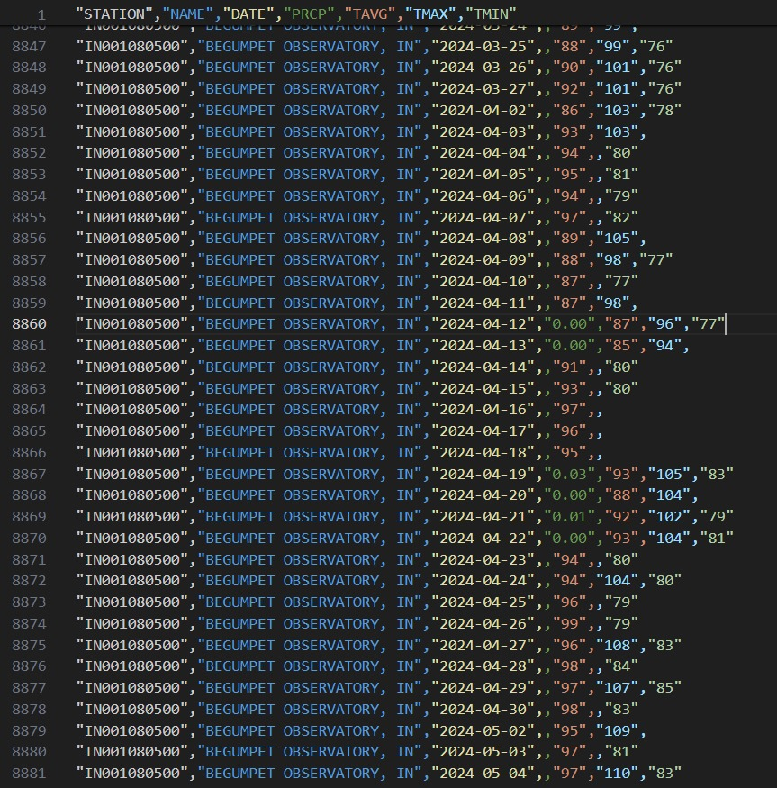

**IMPLEMENTATION AND RESULTS**

Users could input their location or utilize geolocation for automatic retrieval of weather data. The system displayed current weather conditions and forecasts comprehensively, including temperature, humidity, wind speed, and precipitation. Performance optimization measures ensured smooth operation and fast response times, contributing to a positive user experience overall. The system successfully achieved its objectives of providing accurate weather information while maintaining usability and accessibility across various devices.

The weather prediction system was developed using a combination of frontend and backend technologies, leveraging external APIs for weather data retrieval. The frontend interface was designed to be intuitive and visually appealing, with responsive design principles ensuring compatibility across different devices. Error handling mechanisms were integrated to manage API errors effectively and ensure uninterrupted service delivery.

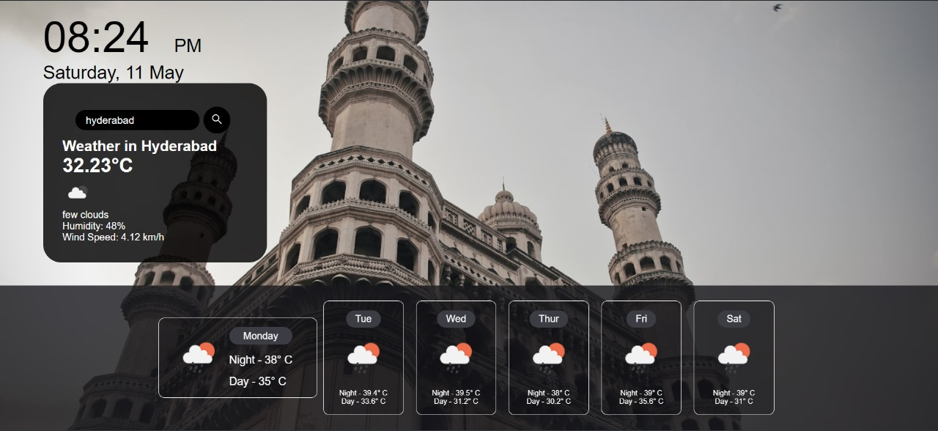

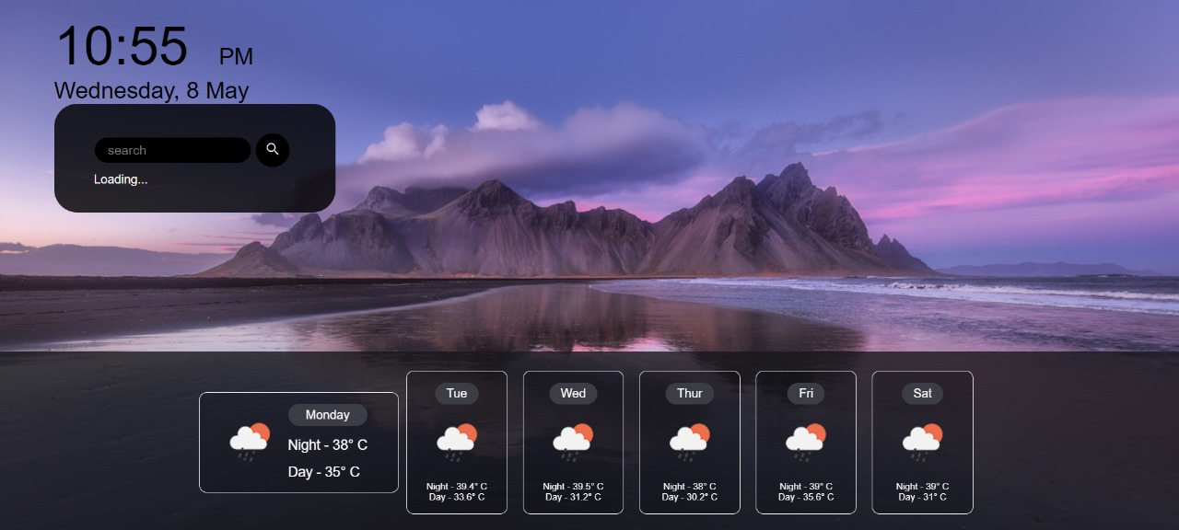

**CONCLUSION :**

In conclusion, the weather prediction system represents a culmination of modern web technologies and robust system design principles to deliver a user-friendly and reliable platform for accessing real-time weather information. The modular architecture ensures scalability and flexibility, while the intuitive user interface enhances usability across diverse devices. Integration with weather data APIs enables seamless retrieval of accurate forecasts, supported by effective error handling and security measures. Performance optimization techniques guarantee fast response times, ensuring a smooth user experience. Thorough testing and documentation further contribute to the system's reliability and maintainability.

**Future Scope**

Moving forward, the weather prediction system can be enhanced with additional features and functionalities to further improve user experience and utility. Potential future developments include the integration of advanced weather visualization tools, such as interactive maps or data-driven charts, to provide users with more comprehensive insights into weather patterns. Furthermore, the system could incorporate personalized alerts and notifications based on user preferences and location-specific weather events. Additionally, expanding the system's capabilities to include predictive analytics and machine learning algorithms could enable more accurate long-term forecasts and insights into evolving weather trends. Continual iteration based on user feedback and advancements in technology will ensure that the weather prediction system remains a valuable resource for users navigating changing weather conditions.

**REFERENCES:**

[1] Department of Environmental and Construction Engineering, University of Central Florida, Orlando, FL(1)

[2] Department of Computer Science, University of USA(1) Massachusetts Boston, Boston,

[3] *Climateof Iowa*, [online] Available: http://www.crh.noaa.gov/Image/dvn/downloads/Clim_IA_01.pdf.

[Google Scholar](https://scholar.google.com/scholar?as_q=Climateof+Iowa&as_occt=title&hl=en&as_sdt=0%2C31)

[4] H. L. Cloke and F. Pappenberger, "Ensemble flood forecasting: a review", Journal of Hydrology, vol. 375, no. 3, pp. 613-626, 2009.

[5]J. Thielen, K. Bogner, F. Pappenberger, M. Kalas, M. Del Medico and A. de Roo, "Monthly - medium - and short - range flood warning: testing the limits of predictability", Meteorological Applications, vol. 16, no. 1, pp. 77-90, 2009.